Plymouth University

School of Computing, Electronics and Mathematics

ISAD251

Database Application Development

2019/2020

BSc (Hons) Computer Information Security

(s) Lee Cadman - 10670374

lee.cadman@students.plymouth.ac.uk

**Table of contents**

Urls and Screenshots………………………………………………….1

Entity Relationship Diagram……………………………………….2

Data Dictionary…………………………………………………………..3

Use Case Diagram……………………………………………………….4

Stored procedure UML………………………………………………..5

UML application architecture…………………………………………………6

Storyboard design for application Feedback………………………….7

URL for GitHub repository : <https://github.com/CadL94/LeesPub>

URL for GitHub prototype page : [https://CadL94.github.io](https://cadl94.github.io/)

URL for API middleware and hosted web pages :

<http://web.socem.plymouth.ac.uk/ISAD251/LCadman> --- Home Page of application

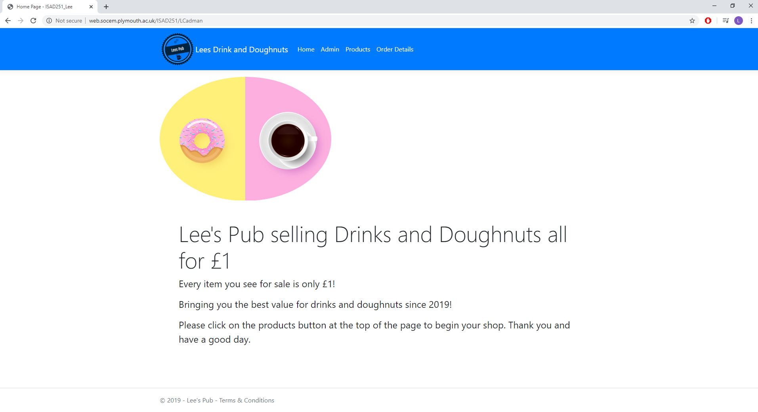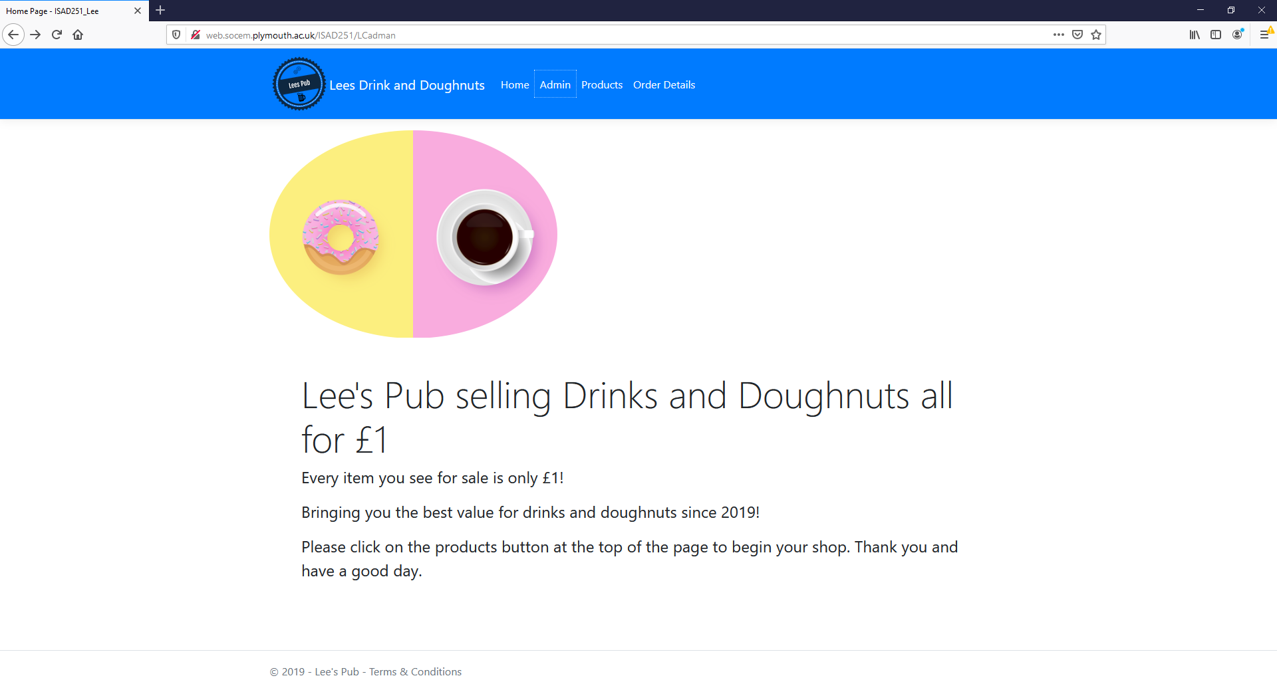Used application on Google Chrome & Mozilla Firefox

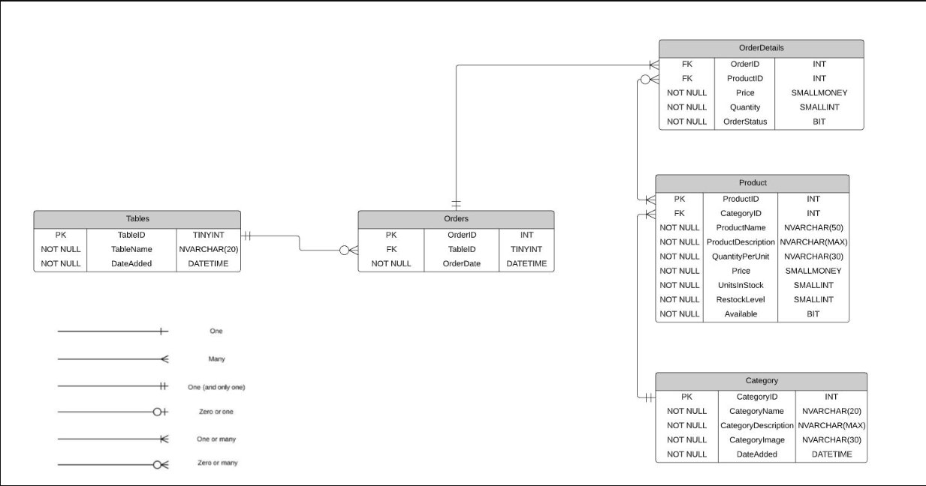 **Entity relationship diagram**

**Data Dictionary**

**Product**

|  |  |  |  |  |  |
| --- | --- | --- | --- | --- | --- |
| **Key** | **Field Name** | **Data Type** | **Null/Not Null** | **References** | **Description** |
| PK | ProductID | INT | NOT NULL |  | Products unique ID number |
| FK | CategoryID | INT | NOT NULL | ‘Category’ table | Category unique ID number |
|  | ProductName | NVARCHAR(50) | NOT NULL |  | Name of products |
|  | ProductDescription | NVARCHAR(MAX) | NOT NULL |  | Description of products |
|  | QuantityPerUnit | NVARCHAR(30) | NOT NULL |  | Quantity per unit |
|  | Price | SMALL MONEY | NOT NULL |  | Price of products |
|  | UnitsInStock | SMALL INT | NOT NULL |  | Units in stock |
|  | RestockLevel | SMALL INT | NOT NULL |  | Level to restock products |
|  | Available | BIT | NOT NULL |  | Product available or not |

**OrderDetails**

|  |  |  |  |  |  |
| --- | --- | --- | --- | --- | --- |
| **Key** | **Field Name** | **Data Type** | **Null/Not Null** | **References** | **Description** |
| FK | OrderID | INT | NOT NULL | ‘Orders’ table |  |
| FK | ProductID | INT | NOT NULL | ‘Product’ table | Products unique ID number |
|  | Price | SMALL MONEY | NOT NULL |  | Price of order |
|  | Quantity | SMALL INT | NOT NULL |  | Quantity of products |
|  | OrderStatus | BIT | NOT NULL |  | Order Status complete or not |

**Orders**

|  |  |  |  |  |  |  |
| --- | --- | --- | --- | --- | --- | --- |
| **Key** | **Field Name** | **Data Type** | **Null/Not Null** | **References** | **Description** |  |
| PK | OrderID | INT | NOT NULL |  | Unique ID when ordering |  |
| FK | TableID | TINY INT | NOT NULL | ‘Tables’ table | Unique Table ID number |  |
|  | OrderDate | DATETIME | NOT NULL |  | Date time of order |  |

**Category**

|  |  |  |  |  |  |
| --- | --- | --- | --- | --- | --- |
| **Key** | **Field Name** | **Data Type** | **Null/Not Null** | **References** | **Description** |
| PK | CategoryID | INT | NOT NULL |  | Category unique ID number |
|  | CategoryName | NVARCHAR(20) | NOT NULL |  | Category name |
|  | CategoryDescription | NVARCHAR(MAX) | NOT NULL |  | Description of category |
|  | CategoryImage | NVARCHAR(60) | NOT NULL |  | Category image |
|  | DateAdded | DATETIME | NOT NULL |  | Date and time category was added |

**Tables**

|  |  |  |  |  |  |
| --- | --- | --- | --- | --- | --- |
| **Key** | **Field Name** | **Data Type** | **Null/Not Null** | **References** | **Description** |
| PK | TableID | TINY INT | NOT NULL |  | Unique Table ID number |
|  | TableName | NVARCHAR(20) | NOT NULL |  | Table name |
|  | DateAdded | DATE TIME | NOT NULL |  | Date and time table was added |

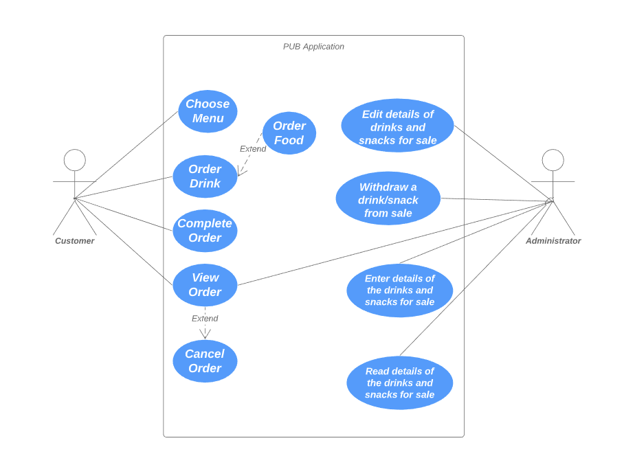 **Use case diagram**

UML for stored procedures

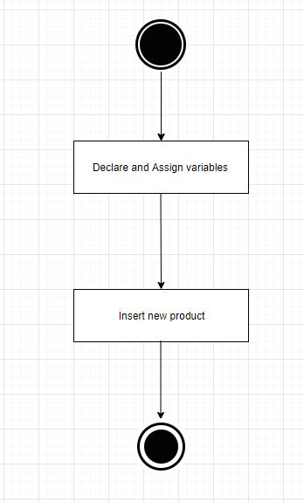

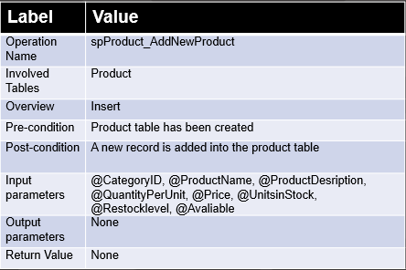

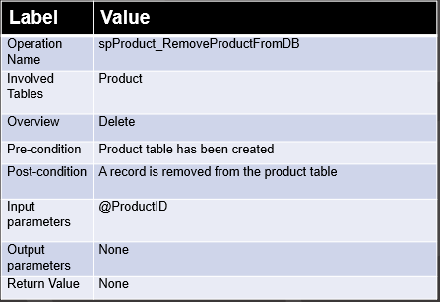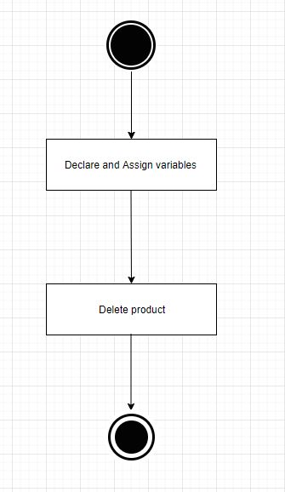

UML application architecture

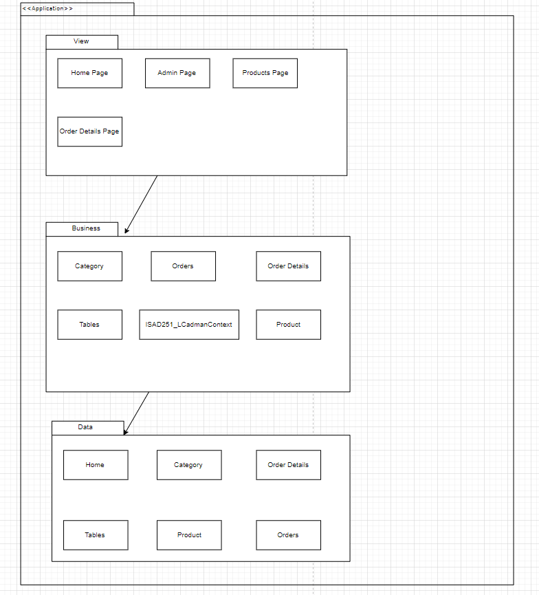

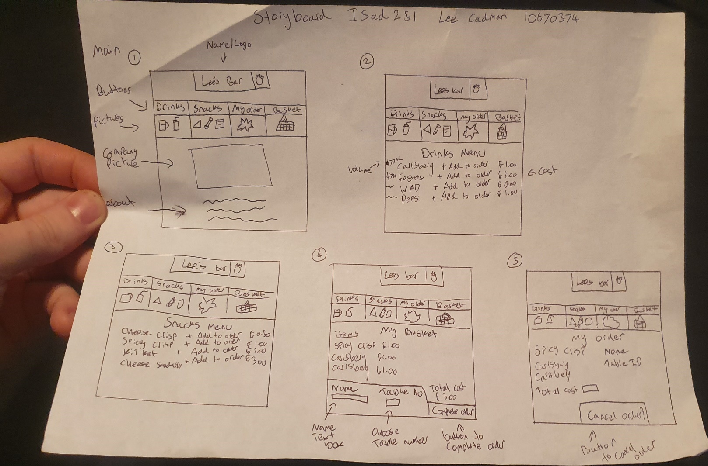 Storyboard design for application + Feedback

Review carried out by : Matt Date 21/10/2019

Buttons need to be clearer so the user can navigate easily.

Need to add remove/edit order buttons to basket.

I took this feedback onboard when designing my application.

**Web Accessibility initiative (WAI)**

Provided clear navigation mechanisms.

Ensured that documents are clear and simple.